2012 Avanti STEM Robotics Invitational
Wednesday, June 6
9:45 – 1:30
Team Guidelines
- School teams may compete in any or all events.
- Individual students may compete in up to 2 events.
- Unique robots (provided they meet the guidelines below) may be used for each event.
- Team rosters identifying participants for each event are due by May 31 so randomized brackets can be created in advance of the competition.
Event Procedures
- During the competition, only students may handle the robots and make changes to programs.
- The three events will be run consecutively to allow all participants to see all events and facilitate individuals competing in more than one event.
- There will be a no-fly zone around each competition arena. Only one operator from each competing team will be allowed inside this zone, and then only for as long as necessary to facilitate the match.
- Teams will be allowed at least 10 minutes to test/adjust their robots under game-day conditions prior to each event.
- Each run of each event will begin with a one minute “call to start” warning. Additional 30s and 10s warning will also be given. Teams unprepared to start on time will forfeit that run.
- The top two teams in each event will be given the opportunity to (and are strongly encouraged to) describe both their hardware and software designs (programs can be shown by projector) and answer questions from other attendees.
Robot Guidelines
Components: All robots will be constructed only from a single 9797 kit (items as listed on the 9797 placards) and the following additional allowed items:
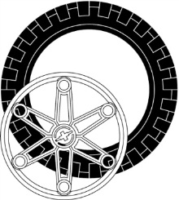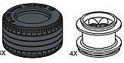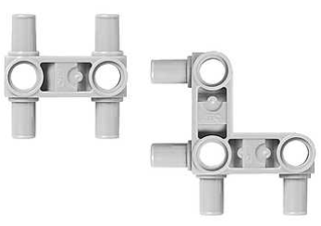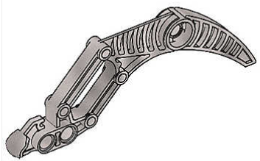
(49.6 x 28 mm)
Large or Lawnmower Wheels (up to 2 each) Snap Beams (up to 10 each) Claw (up to 4)
Size: All robots will fit inside a cube 12 inches on a side.
Exceptions: Dragsters may exceed 12 inches in one dimension.
Sumo-Bots may have appendages that extend out after competition begins.
Liner Racers’ wired-remote controls may extend beyond 12 inches from the robot.
Power: All robots will be powered by a Lego rechargeable battery pack.
Software: All robots will be programmed by NXT-G, RobotC or NXC.
Design Modifications: Either hardware or software may be modified on the day of competition, provided the robot is ready to compete at its designated time.
Remote Control: Dragsters and Sumo-Bots are to run autonomously (with no remote control), not responding to any student input after the “Run” button is pressed. Line Racers may use only wired-remote controls. In no case is wireless robot control allowed.
The Events
Sound Activated Dragsters
This will be a double-elimination competition.
This event will take place on ~4’x8’ whiteboards with center and outer lane markers in 5/8 inch black electrical tape.
Each lane will be approximately 20 feet long and 23 inches wide.
The dragsters will begin racing at the starting “gun” (two pieces of wood clapped together).
The race is over when the first dragster comes to a stop as a result of crossing the finish line.
Each dragster will be positioned at the starting line with its light sensor on the light colored starting line tape (located 18 inches from one end of the course) and its program running.
Note: This means various designs will extend different lengths beyond the starting line, however, each dragster’s light sensor (and hence the dragster itself) will travel the same distance to the finish line.
A maximum of two false-starts per race per entrant will be allowed. Failure to start moving after the “gun” does not constitute a false start.
Any dragster that veers out of its lane will be disqualified in that race.
A dragster may exceed 12” in one dimension.
The light sensor must be mounted at a fixed location of the dragster.
Sumo-bots
This will be a double-elimination competition.
This event will take place on a ~4’x4’ whiteboard with a black border. The arena will be a white square 36” on a side. The arena will be slightly elevated to facilitate timely conclusion of matches.
Sumo-bot wrestling will begin with opponents in opposite corners and will continue until either one opponent is completely out of the arena, or one Sumo-bot is disabled.
The match will begin with a starting gun, so all Sumo-bots must be sound-activated.
If, after one minute, there is no clear winner, the competition will be halted. After a second, abbreviated “call to start” (30 seconds), an additional one minute re-match will begin. For the rematch, Sumo-bots will be placed back-to-back in the center of the arena and must move forward or turn (may not move backwards) immediately after the start of the match. If there is no clear winner after the re-match, judges will declare a winner based on which Sumo-Bot is least disabled, or has most nearly pushed its opponent from the arena during the matches.
The winning robot must either push its opponent completely out of the arena (not counting appendages extending beyond 12”), or disable its opponent (render opponent unable to maneuver, while victor Sumo-bot still can). If a robot is not pushed off the mat, but is flipped, the flipped Sumo-bot is considered disabled and loses the match.
Line Racers
This will be a double-elimination competition.
This event will take place on a ~4’x4’ whiteboard placed on a waist-high table, with the course below marked out in 5/8 inch black electrical tape.
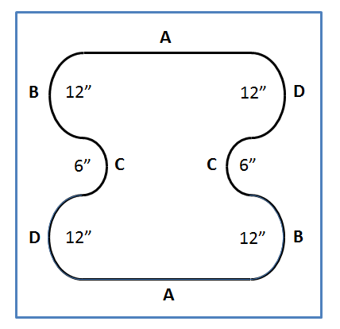
The tape lines will be approximately 7 ½ inches from the edge of the whiteboard on all sides.
The semi-circles at B and D have a 12 inch inner-diameter.
The semi-circles at C have a 6 inch inner diameter.
Racers will start opposite each other at a randomly assigned starting point (A, B, C, or D).
The race will be two laps.
One driver will escort the Line Racer as it travels around the table. While escorting the Line Racer, drivers must avoid contact with each other.
The first Line Racer to cross its original starting position a second time wins. If one Line Racer catches up with its opponent, it will be declared the winner.
Line Racers must follow the line at all times (no straight runs or fixed turns). A line following algorithm must be used at all times during the race.
If a Line Racer “loses” the line, the student may pick up the robot and immediately restart it at the last starting point successful crossed (A, B, C or D).
The wired-remote control may consist of one motor, structural components, and up to two sensors.
At no time can the Line Racer be moved by pulling on the remote control wires.

